**Write a program for FCM.**

**PART-I**

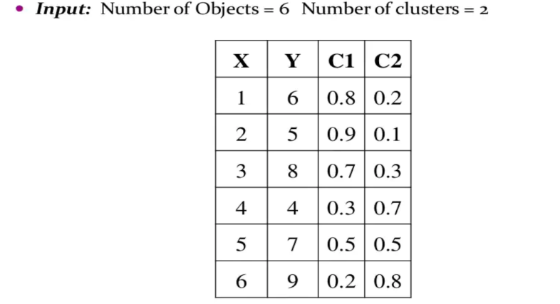

**PART-II**

1. Load modules and training data from sklearn import datasets

In this case (wine dataset): from sklearn.datasets import load_wine

1. Define parameters

Number of Clusters

k = 5

Maximum number of iterations

MAX_ITER = 100

Number of data points

n = len(df)

Fuzzy parameter

m = 1.7 #Select a value greater than 1 else it will be crisp clustering

1. Scatter Plots
2. Initialize membership matrix
3. Calculate Cluster Center
4. Update Membership Value
5. Fuzzy C-Means with cluster centres
6. at origin (**When the initialization is at the origin all points converge into one cluster and for the other 2 cases we get the clusters as we have initialized before**)
7. at random locations within a multi-variate Gaussian distribution with zero-mean and unit-variance.
8. at random vectors chosen from the data.
9. Calculate the Accuracy
10. Plot Data